SS14 Fixed-Income

Thursday, May 23, 2019

3:46 AM

# READING 45. Asset-backed Securities

1. Explain benefits of securitization for economies and financial markets
2. Describe securitization, including the parties involved in the process and the roles they play
3. Describe typical structures of securitizations, including credit tranching and time tranching

* ABS Issue entity: structured finance sector, not corporate
* **Securitization**: benefits to investor: managed credit risk exposure, complex structure; benefits to investors: can expose to a wider range of assets. Parties: seller, SPE(issue ABS), servicer of loans(responsible for payment collection and recovery default); all other underwriters, rating agencies, financial guarantors are third parties.
* Internal **subordination**(aka **credit tranching**): redistribute credit risk associate w collateral, so investors can choose credit risk they bear. Time tranching: diff expected maturities, cuz repayment risk(uncertainty of cash flows not scheduled, extension & contraction risk).
* Absolute priority rule holds in bankruptcy liquidation, violates bankruptcy reorganization.

1. Describe types and characteristics of residential mortgage loans that are typically securitized

* Loan-to-value ratio(LTV): mortgage amount to property's value, lower LTV higher equity. **Mortgage** rate(aka contract, note): fixed, adjustable/variable, initial period fix, convertible. Recourse loan: lender has claim against borrower for any shortfall; Non-recourse loan: no claim but only the sale of property to recover outstanding mortgage.
* Bullet(interest-only lifetime) mortgage: no scheduled principal repmt, payback @maturity.
* **Agency RMBS**: by federal agency & GSE(government-sponsored enterprise); **Non**-agency RMBS: private entities. If not meeting agency RMBS, it's a non-conforming mortgage.

1. Describe types and characteristics of residential mortgage-backed securities, including mortgage pass-through securities and collateralized mortgage obligations, and explain the cash flows and risks for each type

* **Pass**-**through** created when holders form a pool of mortgages and sell shares/certificates in pool; pass-through rate=coupon - serve. Weighted avg coupon rate(WAC), weighted avg maturity(WAM), weighted avg life, prepayment measure of CPR(annualized SSM single).

1. Define prepayment risk and describe the prepayment risk of mortgage-backed securities

* Collagenized mortgage obligation (**CMO**): securitization of a pool of mortgage pass-thru loans. Sequential pay CMO: each tranche retired sequentially; Panned Amortization Class (PAC CMO): predictivity of cash flows following repayment rate; **PCA tranche** has less variability in avg life, **support tranche** has more variability in avg life and can offer higher return bearing prepayment risks(contraction & extension), all compared to mortgage pass-thru securities. CMO and commercial mortgage-backed securities are back by mortgages only.

1. Describe characteristics and risks of commercial mortgage-backed securities(**CMBS**)

* 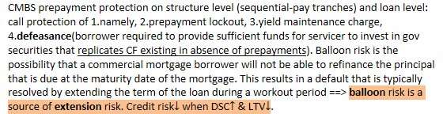

1. Describe types and characteristics of non-mortgage asset-backed securities, including the cash flows and risks of each type

* 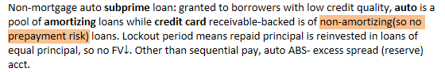

1. Describe collateralized debt obligations, including their cash flows and risks

* Collateralized debt obligation (**CDO**) are structured securities **backed by a pool of debt obligations** that is managed by a collateral manager. ABS collateralize underlying pool of assets; MBS collateralize a pool of mortgage-backed securities. CDO worries additionally manager fails to earn enough returns to pay senior & mezzanine tranches. CDO includes:
* Collateralized bond obligations (CBOs) backed by corporate and emerging market debt.
* Collateralized loan obligations (CLOs) backed by leveraged bank loans.
* **Structured** finance CDOs backed by residential or commercial MBS, ABS, or other CLOs.
* **Synthetic** CDOs backed by credit default swaps on structured securities.

# READING 46. Understanding Fixed Income Risk and Return

1. Calculate and interpret the sources of return from investing in a fixed-rate bond

* 1.Coupon and principle payments, 2.Reinvestment of coupon payments, 3.Capital gains or loss if bond is sold before maturity. A point on **trajectory** represents the carrying value of the bond at that time.

1. Define, calculate, and interpret Macaulay, modified, and effective durations

* 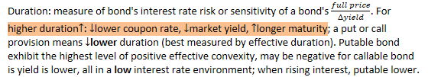
* **Duration gap** = Macaulay duration - investment horizon.

|  |  |
| --- | --- |
| Investment horizon > Macaulay |  |
| Investment horizon = Macaulay | Reinvestment risk offsets price risk |
| Investment horizon < Macaulay |  |

1. Explain why effective duration is the most appropriate measure of interest rate risk for bonds with embedded options
2. Define key rate duration and describe the use of key rate durations in measuring the sensitivity of bonds to changes in the shape of the benchmark yield curve
3. Explain how a bond’s maturity, coupon, and yield level affect its interest rate risk
4. Calculate the duration of a portfolio and explain the limitations of portfolio duration
5. Calculate and interpret the money duration of a bond and price value of a basis point (PVBP)
6. Calculate and interpret approximate convexity and distinguish between approximate and effective convexity
7. Estimate the percentage price change of a bond for a specified change in yield, given the bond’s approximate duration and convexity
8. Describe how the term structure of yield volatility affects the interest rate risk of a bond
9. Describe the relationships among a bond’s holding period return, its duration, and the investment horizon
10. Explain how changes in credit spread and liquidity affect yield-to-maturity of a bond and how duration and convexity can be used to estimate the price effect of the changes

Note: The increase in value of a zero-coupon bond over its life is interest income. A zero-coupon bond has no reinvestment risk over life. A bond held to maturity has no capital gain or loss.

Sources of return from a bond investment include:

* Coupon and principle payments (so-called interest income for zero-coupon)
* Reinvestment of coupon payments
* Capital gain or loss if bond is sold before maturity

△YTM produce market price risk (uncertainty about a bond's price, short-term) and reinvestment risk (uncertainty about income from reinvesting coupon payments, long-term).

When the YTM of a callable bond falls, the increase in price is less than for an option-free bond because both bond price and the value of the call option increase.

Callable bond value = straight bond value - call option value